INDUSTRIAL TRAINING REPORT

On

WEB DEVELOPMENT COURSE

Submitted By

KARTIK VARSHNEY
181500313

Department of Computer Engineering and Applications
Institute of Engineering & Technology

GLA University
Mathura – 281406, INDIA
2020

WEB DEVELOPMENT COURSE Certificate
CERTIFICATE

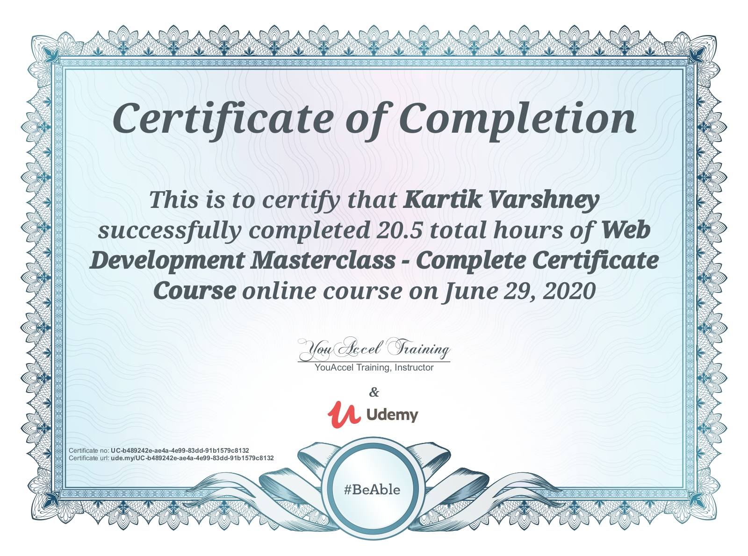

Certificate Link

Dept.of CEA, GLAU, Mathura ii
WEB DEVELOPMENT COURSE Declaration

Department of computer Engineering and Applications
GLA University, Mathura
17 km. Stone NH#2, Mathura-Delhi Road, P.O. – Chaumuha,
Mathura – 281406

Declaration

I hereby declare that the work which is being presented in the Industrial Training “Web Development Course Master Class Complete Certification Course”, in partial fulfilment of the requirements for Industrial Training viva voice, is an authentic record of my own work carried under the supervision of “Udemy” .

Signature of Candidate:

Name of Candidate: Kartik Varshney
Roll. No. : 181500313
Course: B.Tech(CSE)
Year: 2nd Year
Semester: IV

Dept.of CEA, GLAU, Mathura iii
WEB DEVELOPMENT COURSE Abstract

ABSTRACT

WEBSITE DESIGN AND DEVELOPMENT were the main objective of this project. To develop a web based application or software there are several programming languages that are in use. Some of them are only used for the frontend and backend design of the software. For example HTML5, CSS, Bootstrap Framework, Google fonts, Google maps, Google Fonts etc are used for frontend. There are also some other programming languages that are used to develop the dynamic functions of the software or application. For example-PHP, MYSQL etc are used for backend. Nowadays there are also some frameworks that use vastly. Frameworks are basically structured programming by using Model, View, and Controller. It is also called as MVC. If we develop web based application that is very useful for us because we can access it from anywhere of the world. It is very helpful for our daily life. That is why I choose subject of my report is "WEBSITE DESIGN AND DEVELOPMENT". Working in PDF BOOKS added huge experiences in my upcoming career. Solving real life problems was another key issue. This report takes us through all the details of WEBSITE DESIGN AND DEVELOPMENT knowledge and experience gathered during this course period period.

Dept.of CEA, GLAU, Mathura iv
WEB DEVELOPMENT COURSE Acknowledgment

ACKNOWLEDGEMENT
In the present world of competition there is a race of existence in which those are having will come forward succeed. Project like a bridge between theoretical and practical working. With this willing I joined online course because of covid-19 it is not possible to take hand’s on experience in an industry whole world is closed due to this pandemic, So I choose online course of Web Development Masterclass Full Certification course and start learning the content 50-60 min per day and also try to implement the theory on practical to get more detailed knowledge on the particular topic which I learned that day. I would like to thank the supreme power the Almighty God who is obviously the one has always guided me to work on the one has always guided me to work on the right path of life. We would like to express our profound gratitude towards Dr. Anand Mohan Jalal, Dr. Anup Gupta, Dr. Rohit Agrawal for their kind cooperation and encouragement which helped us in completion of project. I am feeling oblige in taking the opportunity to sincerely thanks to Mr. Pankaj Kapoor (Technical Trainer from T&P Dept.) he helped me and guided me to complete my goal and help me to learn new things. I am thankful to my friends who discuss, share the problems, find out the solutions and for the support. Lastly, I would like to thank my parents and family who support me and without whom this project would be just an imagination.

Dept.of CEA, GLAU, Mathura v
WEB DEVELOPMENT COURSE Content

TABLE OF CONTENT

Content Page No.
Certificate ii
Declaration iii
Abstract iv
Acknowledgment v
1. Introduction 8
1.1 Project Objective 8
1.2 Motivation and Overview 8
2. Software Requirement Analysis 9 2.1 Defining Problem Statement 9
2.2 Defining Modules 9
2.3 Functionality Of Modules 10
2.4 External Interfaces Required 10
2.4.1 User Interfaces 10
2.4.2 Hardware Interfaces 10
2.4.3 Software Interfaces 10
3. Software Design 11
3.1 Use Case Diagram 11
3.2 UML Diagrams 12
3.2.1 Class Diagram 12
3.2.2 Data Flow Diagram 12
3.3 Database Design 13
3.3.1 ER Diagram 13
3.3.2 Fields and Data Types 13
4. Implementation and User Interfaces 15
4.1 Languages and Technologies Used 15
4.2 User Interfaces 17
4.3 User Interfaces in Details 18
5. Testing 21
6. Learning Outcomes 22

Dept.of CEA, GLAU, Mathura
WEB DEVELOPMENT COURSE Content

6.1 Technologies 22
6.1.1 HTML 22
6.1.2 CSS 22
6.1.3 Bootstrap 22
6.1.4 PHP 22
6.1.5 JavaScript 23
6.2 Challenges 23
7. References and Bibliography 24

Dept.of CEA, GLAU, Mathura
WEB DEVELOPMENT COURSE Introduction

1. INTRODUCTION

As the world is moving towards the digital era every one wants to be online and already there are many of the organizations which are working online very effectively and help to transform the world. When everyone is working from home during this COVID-19 pandemic so it is good to get the books online. In this course I develop a project which is a website for books in form of PDF which is very helpful for readers and who wants to learn something new.

1.1 PROJECT OBJECTIVES
The purpose of this website is to provide books for those who are interested in reading and wants to develop themselves in this era.
- Most of the text books you can find here from class 5 to class 12.
- You can find novels and magazines as well.
- Also you can find sample papers of that class.
- You can recommand new books to us.

1.2 MOTIVATION AND OVERVIEW
Web development is something where we show some creativity. I have gone through many websites and found how they use their creativity. So I choose this course to learn and create something new. As most of the people are fond of reading. So, I decided to create this project which is about PDF form of books for different type of readers.

In recent time we found that most the people are attract towards online study mode rather than offline study mode as it is easy to adopt the environment. This website contains different kind of books. It contains a form which is for user to recommand some new books to be added. You can contact directly through the given email address

Dept.of CEA, GLAU, Mathura 8
WEB DEVELOPMENT COURSE Software Requirement Analysis

2. SOFTWARE REQUIREMENT ANALYSIS

2.1 DEFINING PROBLEM STATEMENT
“The more that you read, the more things you will know. The more that you learn, the more places you’ll go.”
As you know learning never stops and learner always needs book to learn new things. Sometimes learner did not get the book to learn.

2.2 DEFINING MODULES
This project contains the following modules listed below
1. Index
2. Books
3. Previous papers
4. About Us
5. Contact Us

In these modules some of the modules are for front end which contains HTML5, CSS3, Bootstrap along with PHP and Java Script to interact with the server.

Front-End Modules

1. Index
2. Books
3. Previous papers
4. About Us

Back-End Modules
1. Query or Suggestion Form

Dept.of CEA, GLAU, Mathura 9
WEB DEVELOPMENT COURSE Software Requirement Analysis

2.3 FUNCTIONALITIES OF MODULE
Index: This is page of the website is the landing page of the website which is divided into 5 parts.
1. Top partition of the page contains the company name and address with bold letters.
2. Index page contains navigation bar which contains link to the different modules/pages.
3. Next partition of the page contains image carousal followed by company name and tag line.
4. Next partition again contains an image and some more information about the coffee.
5. It contains footer of the page where copy write mentioned.

Books: This page contains different kinds of books which reader likes to read. On this page books are with cover page and have a option of read more.

Previous Paper: This page contains previous year papers for different standards. You can find out subject wise papers also.

About Us: This page contains the information about the website how it gets to publish and how it is helpful to others.

Contact Us: This page contains the contact information to the PDF BOOKS administration through E-mail and phone number. In this page there is a form for query or suggestions.

2.4 EXTERNAL INTERFACES REQUIRED

2.4.1 User Interfaces
- Front-end
2.4.2 Hardware Interfaces Required
- Desktop or Laptop with minimum 4GB of RAM
- Processor : intel i3 minimum
2.4.3 Software Interfaces Required
- VS code editor
- XAMPP server
- Google chrome (any browser that supports JS, CDN, HTML, CSS, and PHP)

Dept.of CEA, GLAU, Mathura 10
WEB DEVELOPMENT COURSE Software Design

3. SOFTWARE DESIGN

3.1 USE CASE DIAGRAM

In this project PDF BOOKS is basically a website for a readers and students which provides various facilities to the user/customer who visit the website so it mainly consist of one main actor here it is USER which can perform various activities on website .

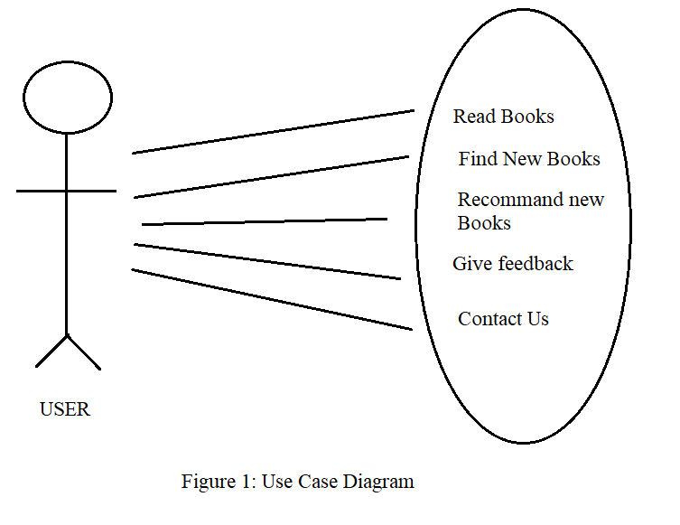
There are various functionality like finding new books to know more about power of books and read new books to know more interesting fact about different type of books, customer can also be able to give feedback regarding website, through contact us section.

Dept.of CEA, GLAU, Mathura 11
WEB DEVELOPMENT COURSE Software Design

3.2 UML DIAGRAMS

3.2.1 CLASS DIAGRAM

There is a class on which I worked and this class provide the functionality of Contact to the owner regarding issues, recommendations and for valuable feedback.

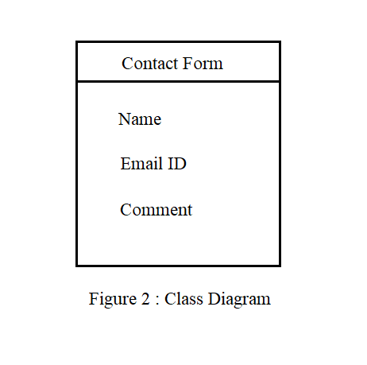

3.2.2 DATA FLOW DIAGRAM
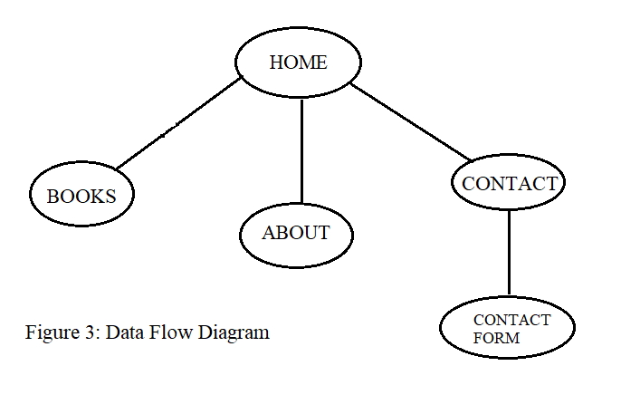

Dept.of CEA, GLAU, Mathura 12
WEB DEVELOPMENT COURSE Software Design

Above Diagram is the data flow diagram of the project which shows how data flow between various modules of the website. When user opens. website he/she lands on home page then according to the choice he/she navigate through out the website according to their need

3.3 DATABASE DESIGN

3.3.1 E-R DIAGRAM

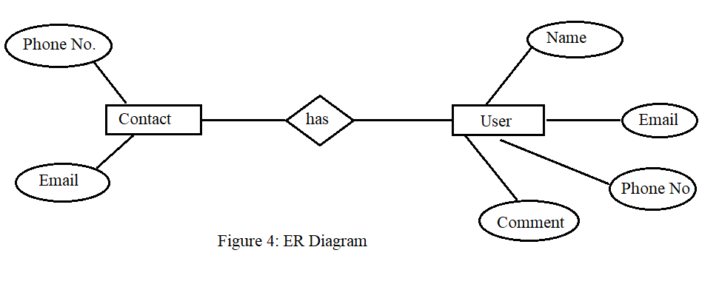

3.3.2 FIELDS AND DATA TYPES

`id` int(15) NOT NULL AUTO_INCREMENT,
`name` varchar(25) COLLATE utf8_unicode_ci NOT NULL,
`email` varchar(25) COLLATE utf8_unicode_ci NOT NULL,
`comment` varchar(250) COLLATE utf8_unicode_ci NOT NULL,
PRIMARY KEY (`id`)

These above two figures give a brief introduction about the database design and database schema. Whole website has two main modules that uses database that is login module and registration module. In login module it directly related to the member database and verify and fetch the details from the member database and above is the scheme of the member database. Whenever a new user visit to the website then new user must have to register on the website, for registration purpose
Dept.of CEA, GLAU, Mathura 13
WEB DEVELOPMENT COURSE Software Design

database use registration module which ask user for the relevant information to register on the on the website. All the data store in member database that contains various attributes like name, email, phone number and comment.

Dept.of CEA, GLAU, Mathura 14
WEB DEVELOPMENT COURSE Implementation and User Interface

4. IMPLEMENTATION AND USER INTERFACE

4.1 LANGUAGES AND TECHNOLOGIES USED IN IMPLEMENTATION

- HTML5
- CSS3
- Bootstrap
- JavaScript / JQuery
- PHP
- OOP
- MySQL

HTML: Hypertext Markup Language (HTML) is the standard markup language for documents designed to be displayed in a web browser. It can be assisted by technologies such as Cascading Style Sheets (CSS) and scripting languages such as JavaScript. Web browsers receive HTML documents from a web server or from local storage and render the documents into multimedia web pages. HTML describes the structure of a web page semantically and originally included cues for the appearance of the document.

HTML elements are the building blocks of HTML pages. With HTML constructs, images and other objects such as interactive forms may be embedded into the rendered page. HTML provides a means to create structured document by denoting structural semantic for text such as headings, paragraphs, lists, links, quotes and other items. HTML elements are delineated by tags, written using angle brackets.

CSS3: Cascading Style Sheets(CSS) is a style sheet language used for describing the presentation of a document written in a markup language like HTML. CSS is a cornerstone technology of the World Wide Web, alongside HTML and JavaScript.
CSS is designed to enable the separation of presentation and content, including layouts, colours, and fonts. This separation can improve content accessibility, provide more flexibility and control in the specification of presentation characteristics, enable multiple web pages to share formatting by specifying the relevant CSS in a separate .css file which reduces complexity and repetition in the

Dept.of CEA, GLAU, Mathura 15
WEB DEVELOPMENT COURSE Implementation and User Interface

structural content as well as enabling the .css file to be cached to improve the page load speed between the pages that share the file and its formatting.

BOOTSTRAP: Bootstrap is a web framework that focuses on simplifying the development of informative web pages (as opposed to web apps). The primary purpose of adding it to a web project is to apply Bootstrap's choices of colour, size, font and layout to that project. As such, the primary factor is whether the developers in charge find those choices to their liking. Once added to a project, Bootstrap provides basic style definitions for all HTML elements. The result is a uniform appearance for prose, tables and form elements across web browsers. In addition, developers can take advantage of CSS classes defined in Bootstrap to further customize the appearance of their contents. For example, Bootstrap has provisioned for light- and dark-coloured tables, page headings, more prominent pull quotes, and text with a highlight.

JAVASCRIPT: JavaScript often abbreviated as JS, is a programming language that conforms to the ECMAScripts specification. JavaScript is high-level, often just-in-time compiled, and multi-paradigm. It has curly-bracket syntax, dynamic typing, prototype-based object-orientation, and first-class functions.
Alongside HTML and CSS, JavaScript is one of the core technologies of the World Wide Web. JavaScript enables interactive web pages and is an essential part of web applications. The vast majority of websites use it for client-side page behavior, and all major web browsers have a dedicated JavaScript engine to execute it.

JQUERY: jQuery, at its core, is a Document Object Model (DOM) manipulation library. The DOM is a tree-structure representation of all the elements of a Web page. jQuery simplifies the syntax for finding, selecting, and manipulating these DOM elements. For example, jQuery can be used for finding an element in the document with a certain property (e.g. all elements with an h1 tag), changing one or more of its attributes (e.g. colour, visibility), or making it respond to an event (e.g. a mouse click).

PHP: PHP is a general-purpose scripting language that is especially suited to web development. PHP originally stood for Personal Home Page, but it now stands for the recursive initialism PHP:

Dept.of CEA, GLAU, Mathura 16
WEB DEVELOPMENT COURSE Implementation and User Interface

Hypertext Preprocessor. PHP code is usually processed on a web server by a PHP interpreter implemented as a module, a daemon or as a Common Gateway Interface (CGI) executable. On a web server, the result of the interpreted and executed PHP code – which may be any type of data, such as generated HTML or binary image data – would form the whole or part of a HTTP response.

OOP: Object-oriented programming (OOP) is a programming paradigm based on the concept of "objects", which can contain data and code: data in the form of fields (often known as attributes or properties), and code, in the form of procedures (often known as methods). A feature of objects is that an object's own procedures can access and often modify the data fields of itself (objects have a notion of "this" or "self"). In OOP, computer programs are designed by making them out of objects that interact with one another. OOP languages are diverse, but the most popular ones are class-based, meaning that objects are instances of classes, which also determine their types.

MYSQL: MySQL is free and open-source software under the terms of the GNU General Public License, and is also available under a variety of proprietary licenses. MySQL was owned and sponsored by the Swedish company MySQL AB, which was bought by Sun Microsystems (now Oracle Corporation). In 2010, when Oracle acquired Sun, Widenius forked the open-source MySQL project to create MariaDB. MySQL has stand-alone clients that allow users to interact directly with a MySQL database using SQL, but more often MySQL is used with other programs to implement applications that need relational database capability. MySQL is a component of the LAMP web application software stack (and others), which is an acronym for Linux, Apache, MySQL, Perl/PHP/Python. MySQL is used by many database-driven web applications, including Drupal, Joomla, phpBB, and WordPress. MySQL is also used by many popular websites, including Facebook, Flickr, MediaWiki, Twitter, and YouTube.

4.2 USER INTERFACES

There are mainly 5 pages that are interact with user directly :
- Index / Home
- Books
- Previous Papers
- About Us
- Contact
Dept.of CEA, GLAU, Mathura 17
WEB DEVELOPMENT COURSE Implementation and User Interface

4.3 USER INTERFACES IN DETAIL
Home Page : Contains a simple carousal, then it have some testimonials of books, after that a brief about us section and at last footer is there.
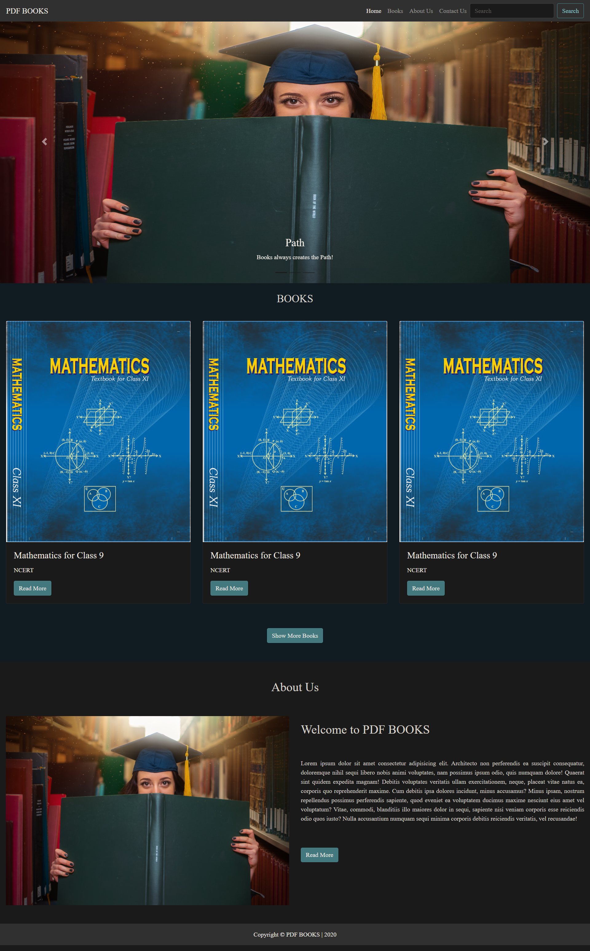

Dept.of CEA, GLAU, Mathura 18
WEB DEVELOPMENT COURSE Implementation and User Interface

Books Page : It contains different books to read and learn.
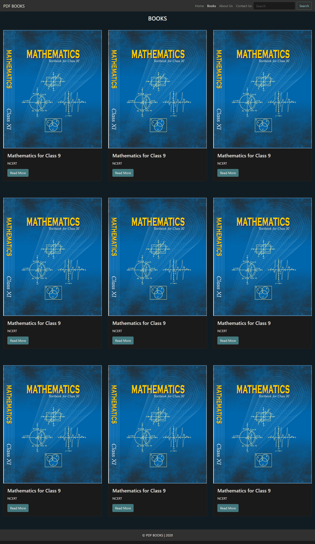
Dept.of CEA, GLAU, Mathura 19
WEB DEVELOPMENT COURSE Implementation and User Interface
About Us Page : It contains about the website how it is helpful to students and readers.
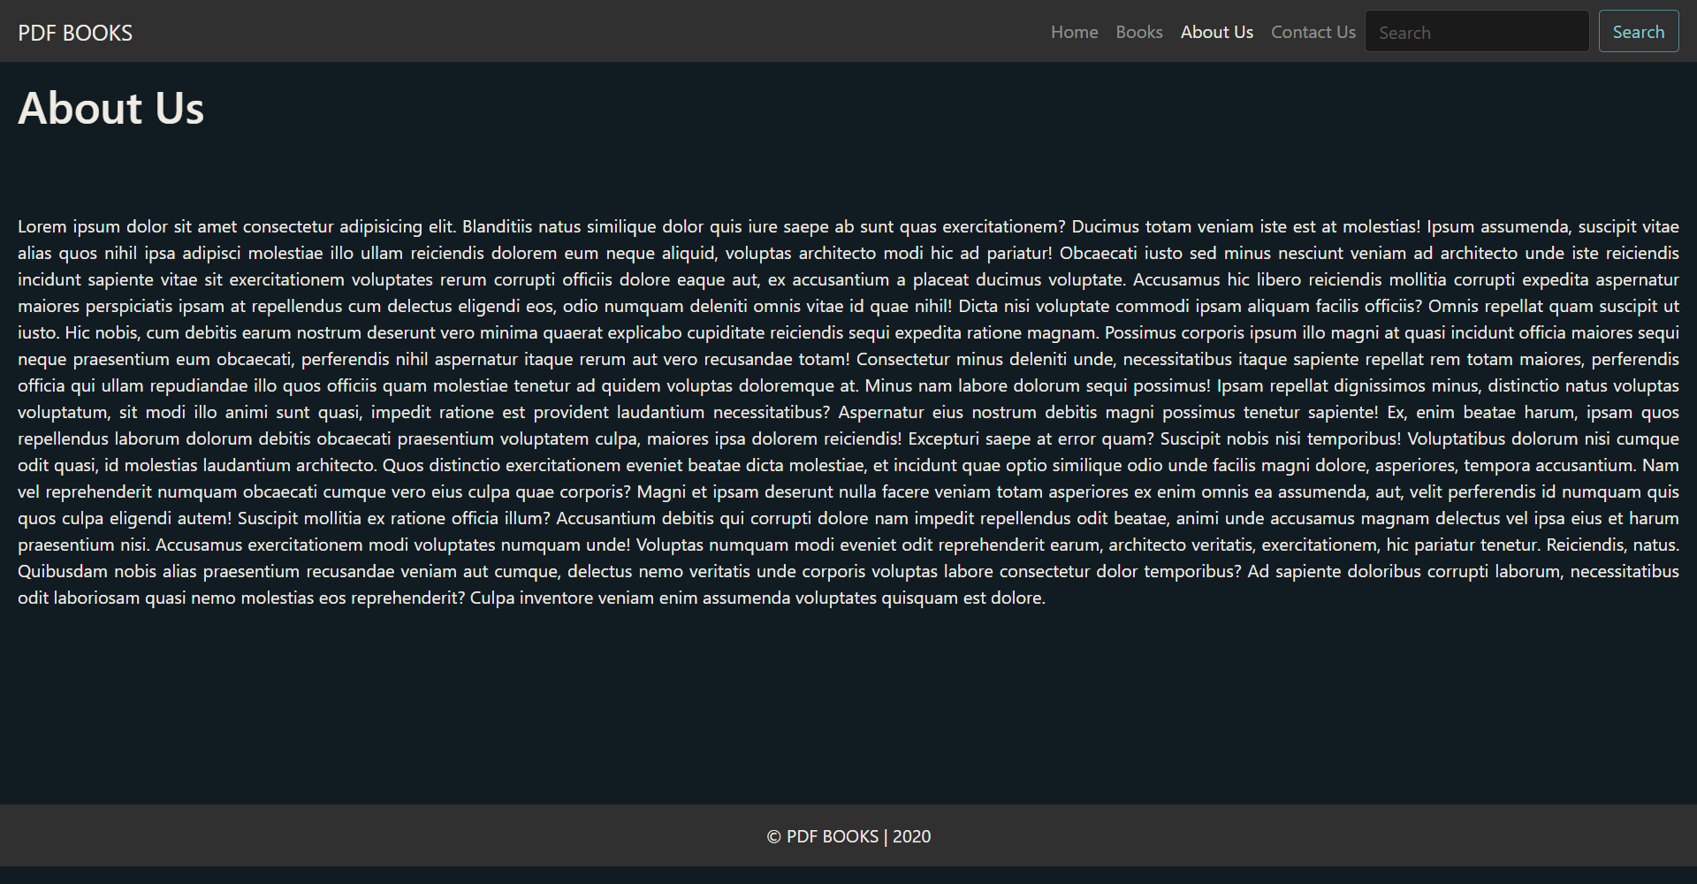
Contact Us Page : It contains basic contact information and a contact form for feedback, query or suggestions.

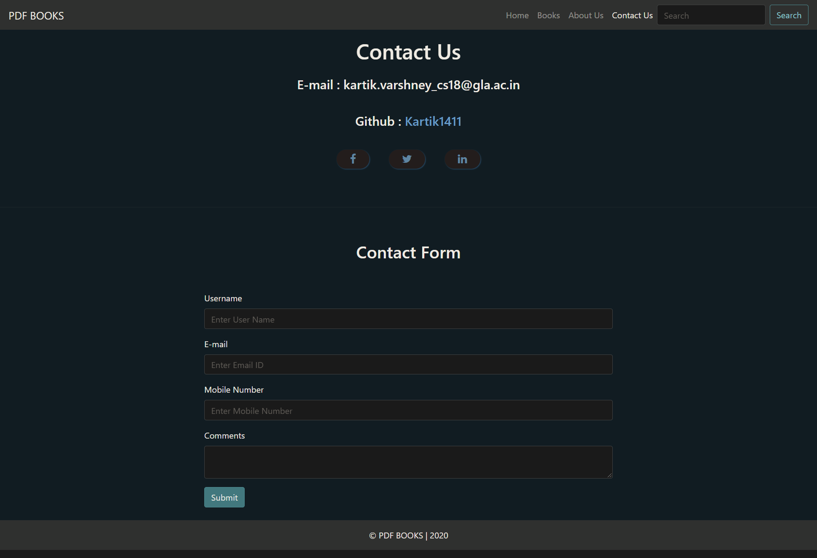
Dept.of CEA, GLAU, Mathura 20
WEB DEVELOPMENT COURSE Testing

5. TESTING
In testing phase of the project I mainly worked upon the front-end technologies of the project so I tested my website on different devices with different resolutions. Check all the buttons are working perfectly or not.
Check and verify all the CDN used in this project.
Analyse and test the front-end code.
Use Chrome extension for CSS and other technologies.

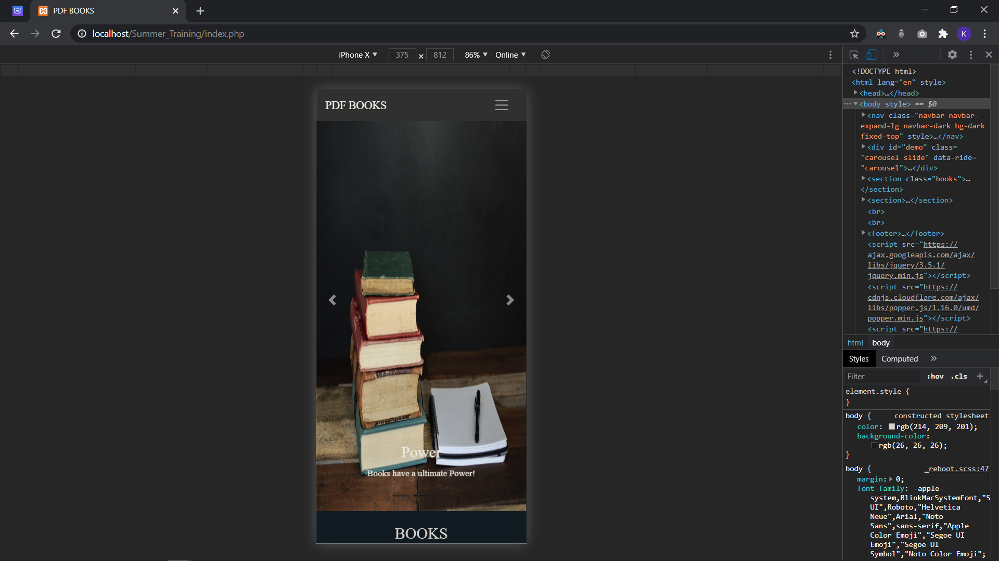
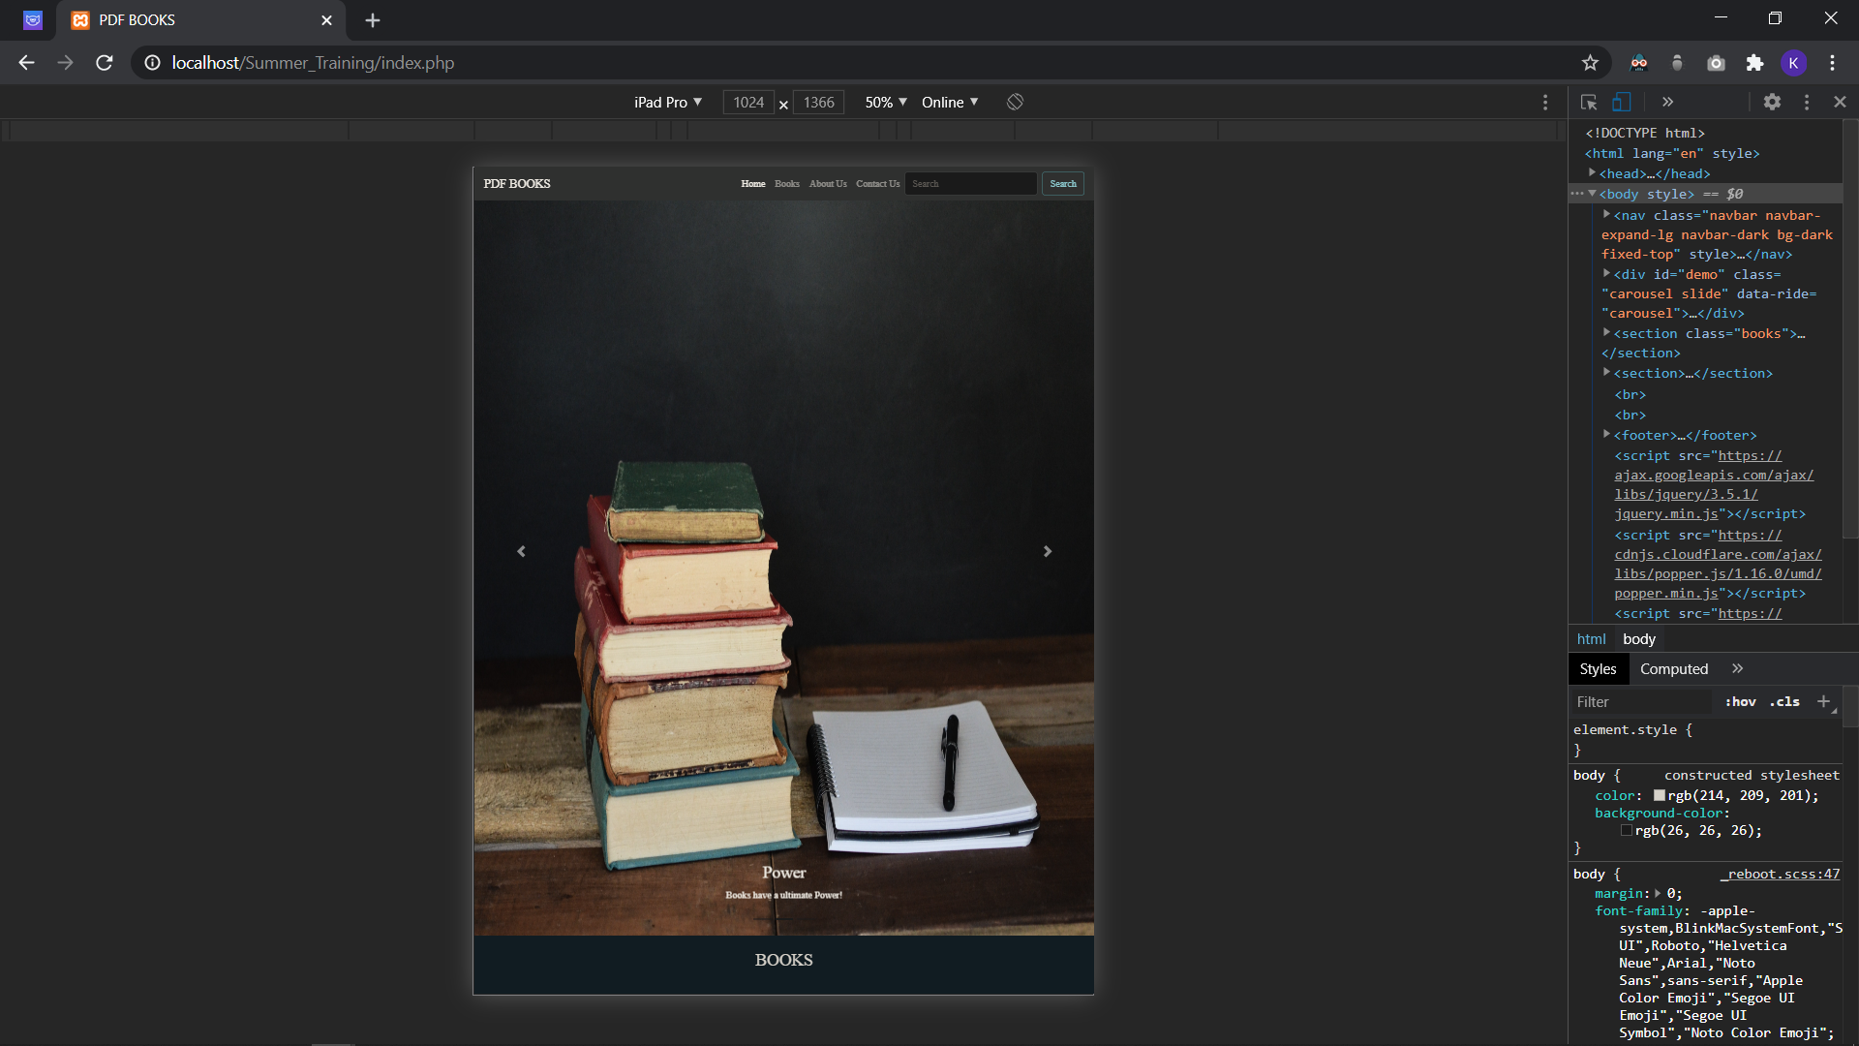

Website is responsive on different screen sizes.

Dept.of CEA, GLAU, Mathura 21
WEB DEVELOPMENT COURSE Learning Outcomes

6. LEARNING OUTCOMES
6.1 TECHNOLOGIES
6.1.1 HTML
- Basic concept (WWW& HTTP, HTTPS, Client Server Communication)
- Basic HTML (Tags, Element, Attributes, Paragraphs, Headings, Line Breaks, Horizontal Rule, Lists, Table, Color Codes, Font, Text Linking, Email, Images, Background, Comments, Meta, Media, Charset)
- HTML Forms (Input, Text Fields, Password, Checkbox, Combo Box, Radio, Text Areas, Files, Buttons)
- HTML5 features and Benefits

6.1.2 CSS
- Basic CSS (selector, internal, external, Inline, Class, Id, Background, Font, Text, Padding, Margin, Border, List CSS, Hovering, Animations and elements)
- Advance CSS (border-radius, opacity, cursor, layers, position, display, float, gradient, and multiple-column)
- Concept of Menus (single menu, drop-down menu)
- Template, design using CSS div

6.1.3 BOOTSTRAP
- Environment Setup
- Grid System
- Typography
- Drop-down, Button group
- Tables, Forms, Buttons, Images
- Navigation Element
- Bootstrap plug-ins (Transition, Modal, Dropdown, Tab, Tooltip, Alert, Button)

6.1.4 PHP
- Control Structures (if, else, else if, while, do-while, for, for each, break, continue, switch)
- Include (require, include, require_ once, include_ once)
- Function (User-defined Function, Function arguments, returning values, variables function)
Dept.of CEA, GLAU, Mathura 22
WEB DEVELOPMENT COURSE Learning Outcomes

- Array (array declaration, merging, sorting, deleting, inserting)

6.1.5 JAVASCRIPT
- Control Structures (if, else, else if, while, do-while, for, for each, break, continue, switch)
- Function (User-defined Function, Function arguments, returning values, variables function)
- Array (array declaration, merging, sorting, deleting, inserting)

6.2 CHALLENGES

There are many types of challenges that I faced during this Project and Completion of Course but at the end of this course and project I learned a lot and acquire a great experience of working on project that related to real world problem.

Here are some most common challenges that I faced during this Project and Course:

• Learning some new language
• Working on different language at same time
• Managing coordination between all the modules
• Syntactical Errors
• Connectivity issue between front end and back end
• Network issue
• Fatal Error
• Finding problem and try to solve them on our own with the help of articles and some other references

Dept.of CEA, GLAU, Mathura 23
WEB DEVELOPMENT COURSE References And Bibliography

7. REFERENCES AND BIBLIOGRAPHY

1. Robin Nixon Learning PHP, MYSQL and Java Script with Jquery, CSS & HTML5: O’RELLY 4th Edition 2014.

2. Udemy Web Development master class Complete Certification Course https://www.udemy.com/course/web-development-masterclass-complete-certificatecourse/

3. Macy Storm D2C Website Examples: 6 Examples of Direct to Consumer brands https://www.webfx.com/blog/web-design/d2c-website-examples/

4. Beta Labs Introduction to HTML https://www.beta-labs.in/2020/06/introduction-tohtml.html

5. Beta Labs Introduction to CSS https://www.beta-labs.in/2020/07/introduction-tocss.html

6. Beta Labs Introduction to PHP https://www.beta-labs.in/2020/05/introduction-tophp.html

7. MDN Web Docs HTML: Hyper text Markup Language https://developer.mozilla.org/en-US/docs/Web/HTML

8. MDN Web Docs CSS : Cascading Style Sheet https://developer.mozilla.org/en-US/docs/Web/CSS

9. MDN Web Docs JavaScript https://developer.mozilla.org/en-US/docs/Web/JavaScript

10. Code With Harry Complete PHP https://www.youtube.com/watch?v=at19OmH2Bg4&list=PLu0W_9lII9aikXkRE0WxDt1vozo3hnmtR&ab_channel=CodeWithHarry

11. Silberschatz−Korth−Sudarshan Database System Concepts, 4 th Edition : The McGraw−Hill Companies, 2001

Dept.of CEA, GLAU, Mathura 24
WEB DEVELOPMENT COURSE References And Bibliography

12. FontAwsome Uses of Fonts and Icons https://fontawesome.com/

13. BootStrap BootStrapDocumentation https://getbootstrap.com/

14. www.quora.com https://www.quora.com/topic/What-Are-Benefits-of-a-DevelopersHow-good- Are-Opportunities-in-the-current-marke

15. Quora What is the difference between creating a website using sites such as WordPress, and by using programming languages such as JavaScript, HTML, Python, etc.
https://www.quora.com/What-is-the-difference-between-creating-a-website-using-sites-such-as-WordPress-and-by-using-programming-languages-such-as-JavaScript-HTML-Python-etc#:~:text=There%20is%20big%20difference%20between,have%20knowledge%20of%20coding%20la

Dept.of CEA, GLAU, Mathura 25

